Name: B Tharun kumar
Reg No: 192424356
Course Name: Computer Networks for Software Application
Code: CSA-0713
Lab Experiments: 1-35

1.Configuration of Network Devices using Packet Tracer tools (Hub, Switch, Ethernet, Broadcast)
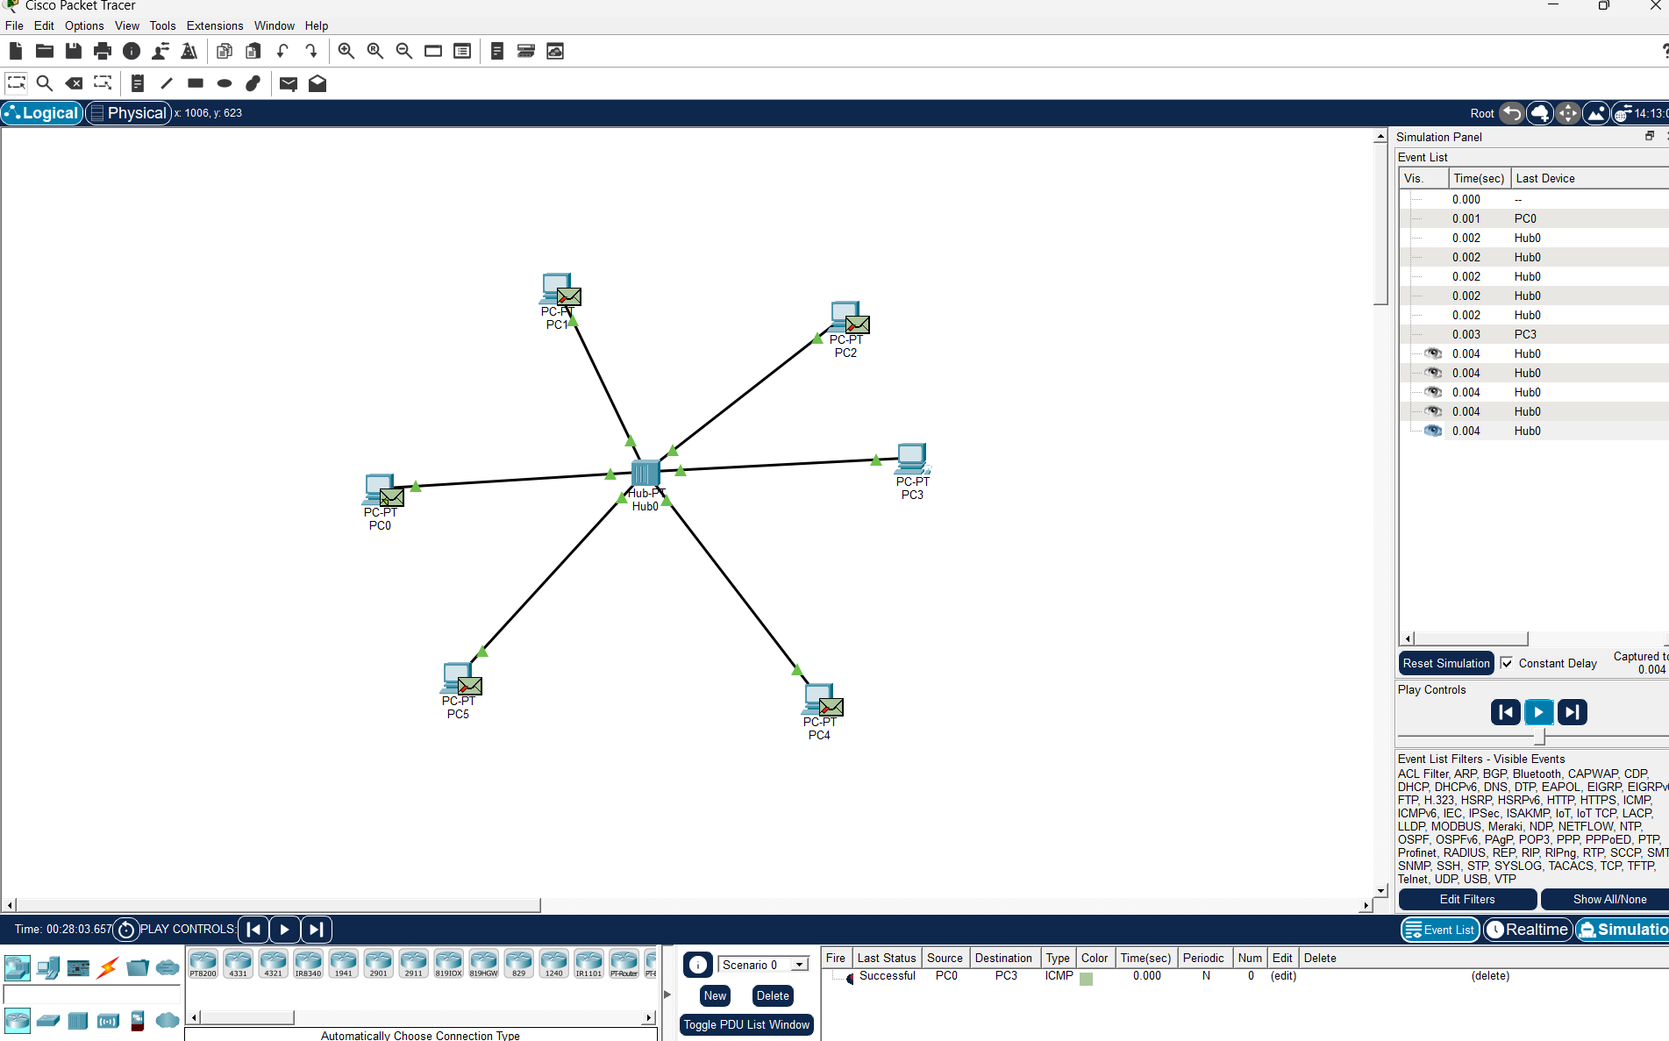

- Design and Configuration of Star Topologies using Packet Tracer Star Topology using Hub:
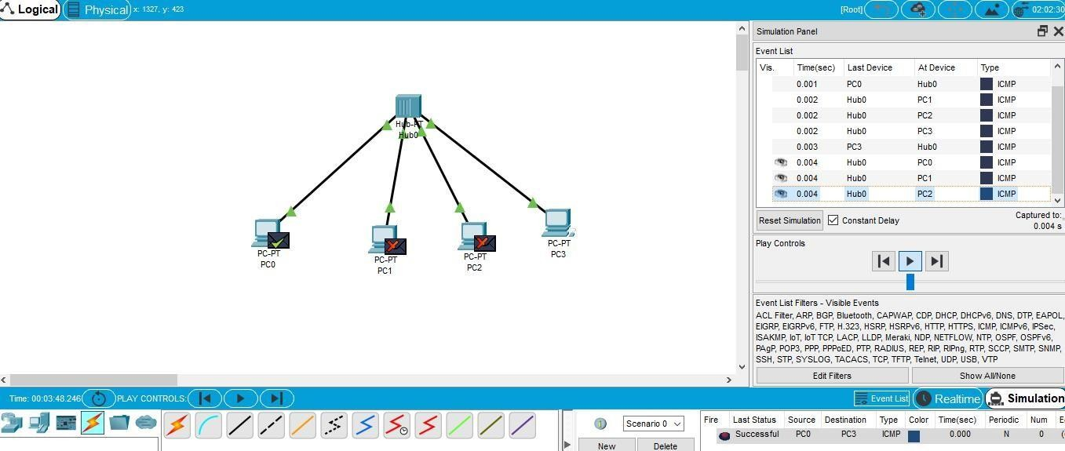

Star Topology using Switch:

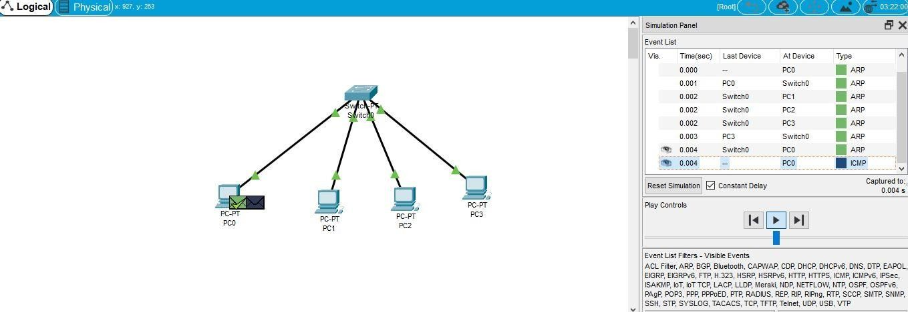

- Design and Configuration of BUS Topologies using Packet Tracer.
Bus Topology using Hub:
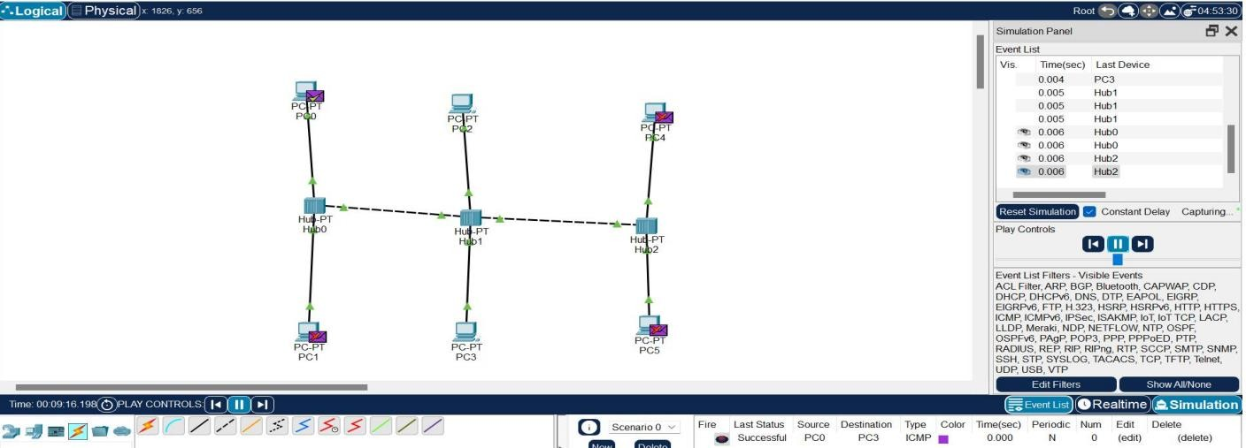
Bus Topology using Switch:
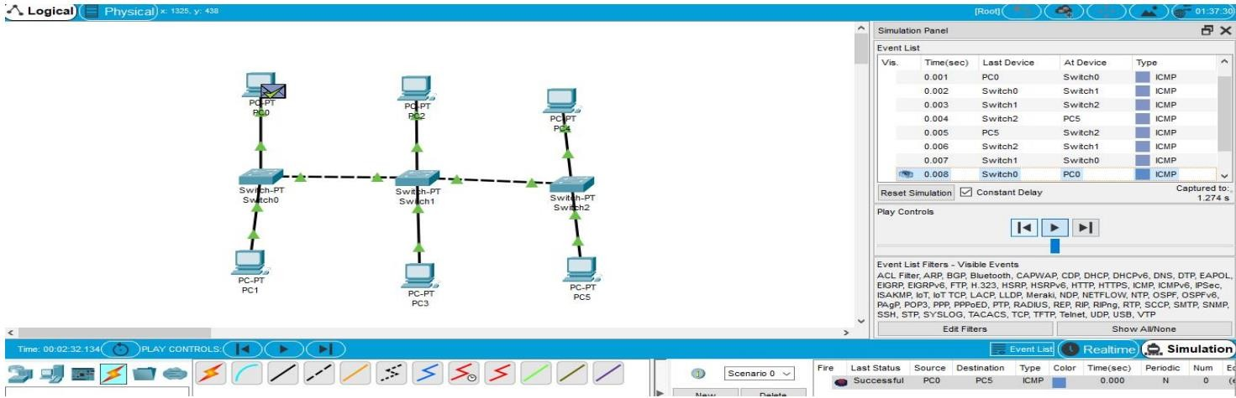

- Design and Configuration of RING Topologies using Packet Tracer
Ring Topology using Hub:
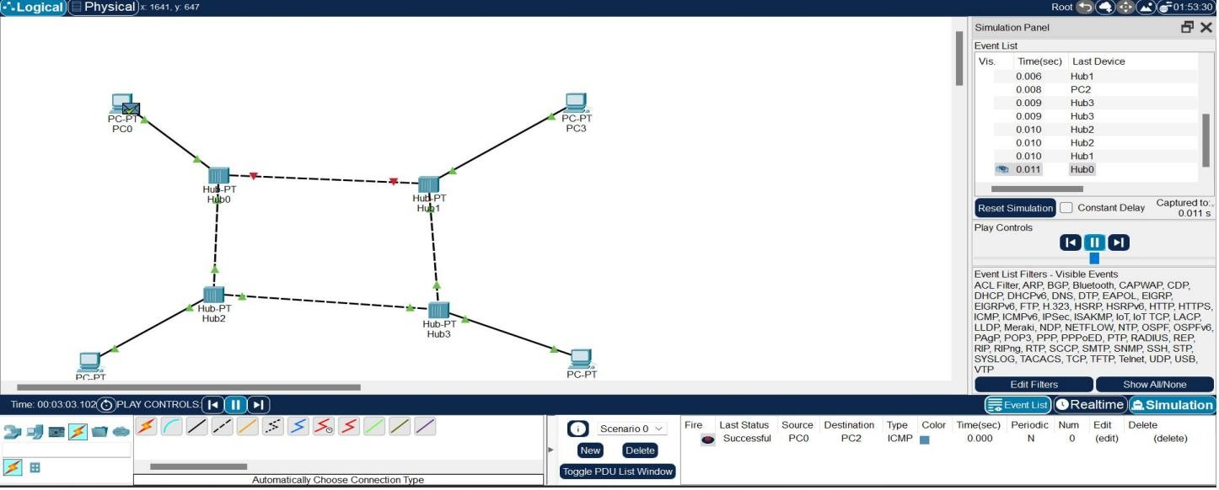
Ring Topology using Switch:
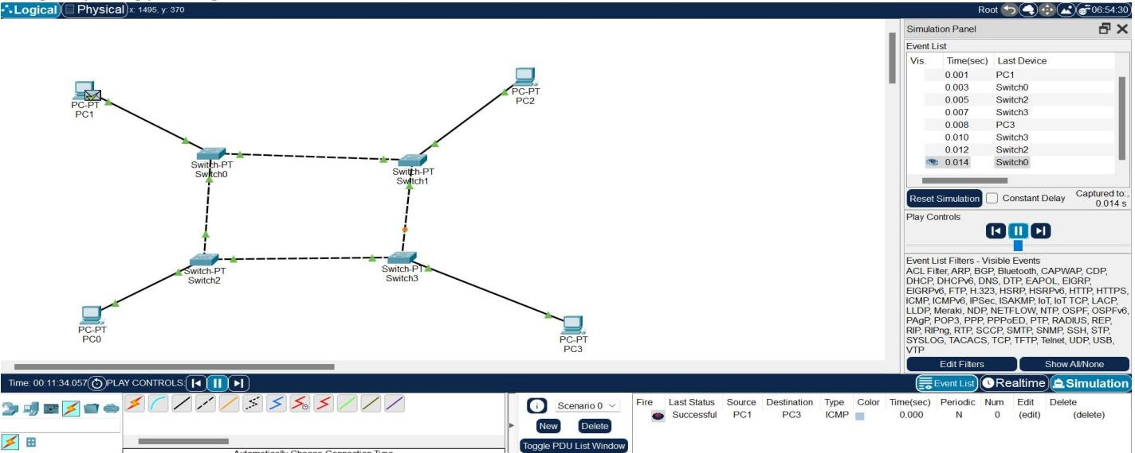

- Design and Configuration of Mesh Topologies using Packet Tracer Mesh Topology using Hub:
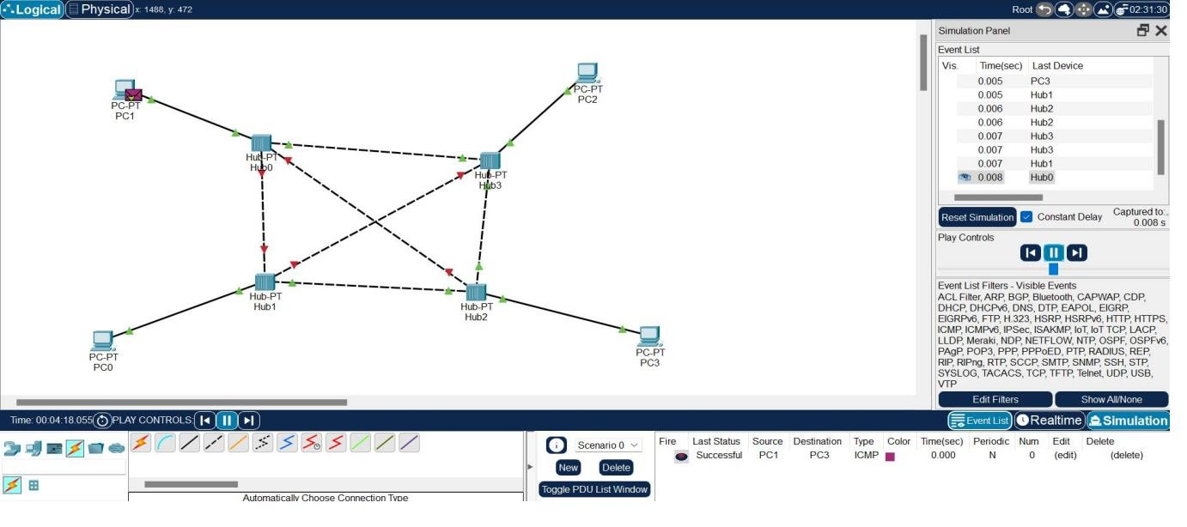

Mesh Topology using Switch:
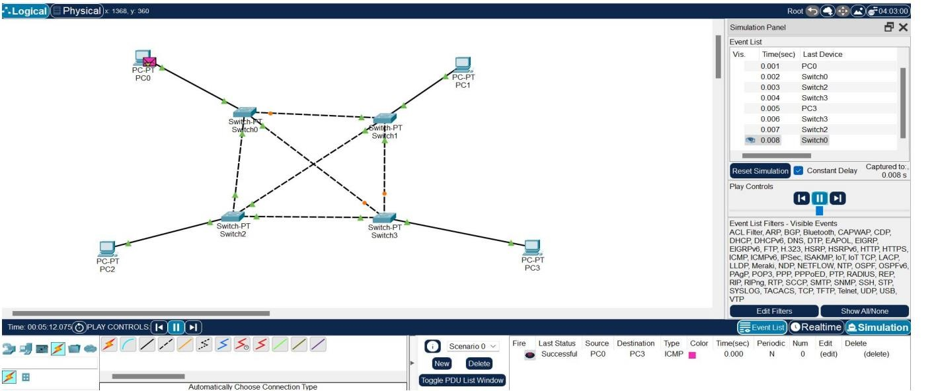

6.Design and Configuration of Tree Topologies using Packet Tracer.
Tree Topology using Hub:
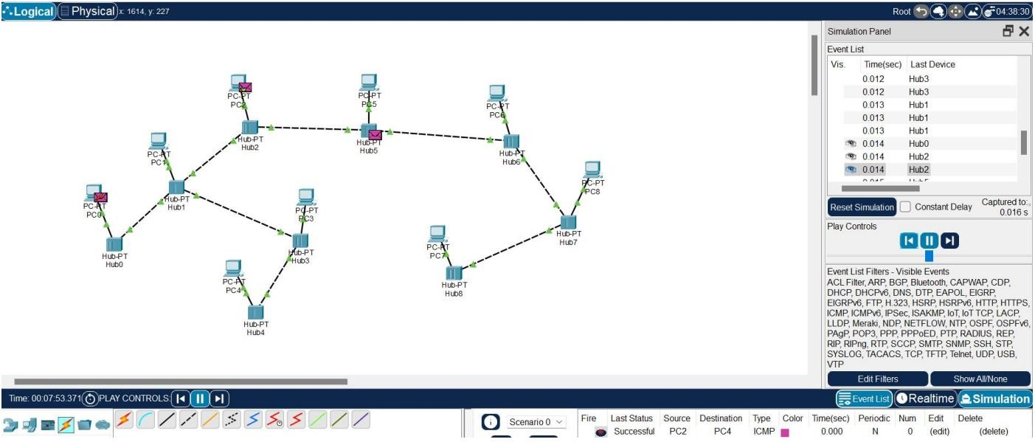
Tree Topology using Switch:
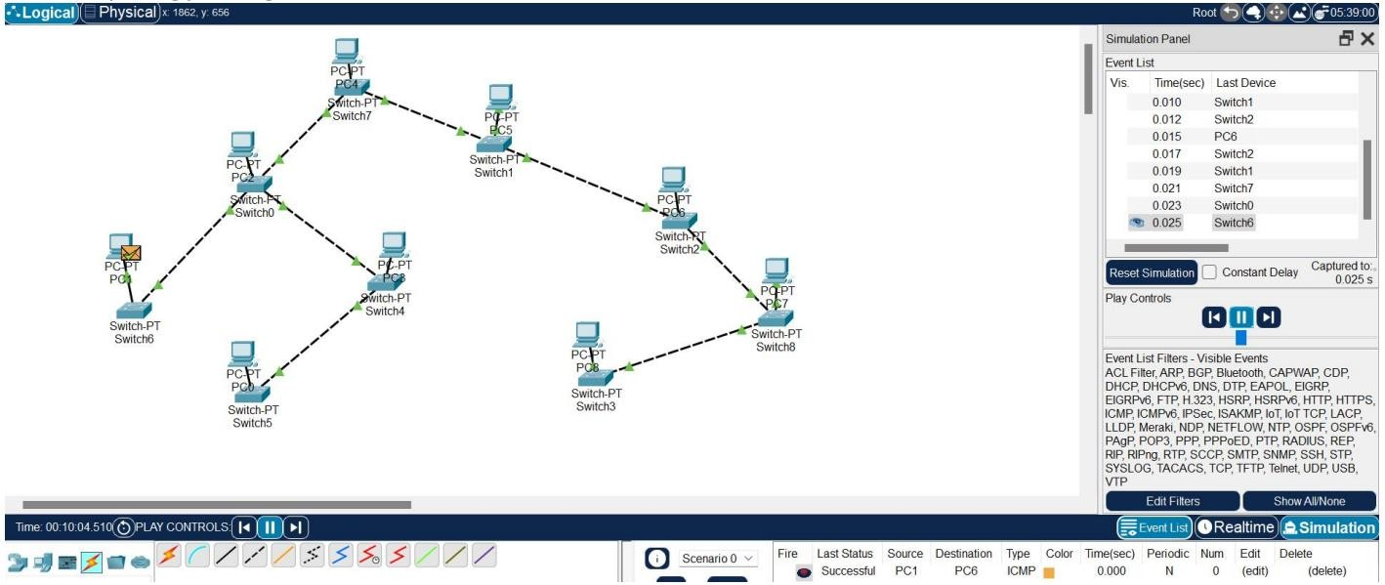

- Design and Configuration of Hybrid Topologies using Packet Tracer
Hybrid Topology using Hub:
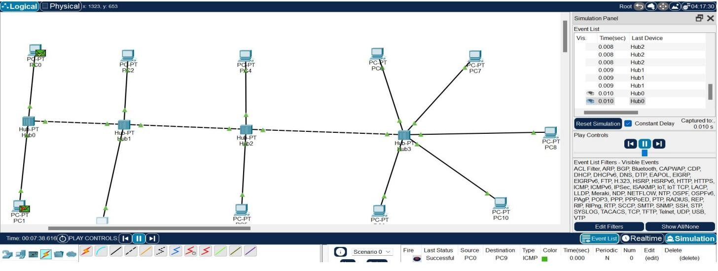
Hybrid Topology using Switch:
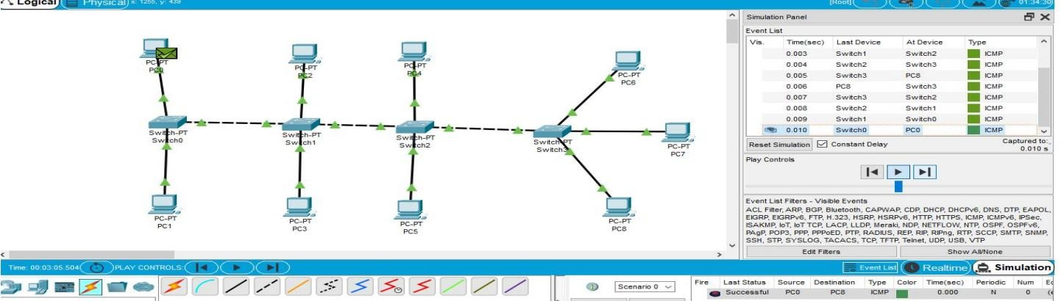

- Data Link Layer Traffic Simulation using Packet Tracer Analysis of ARP
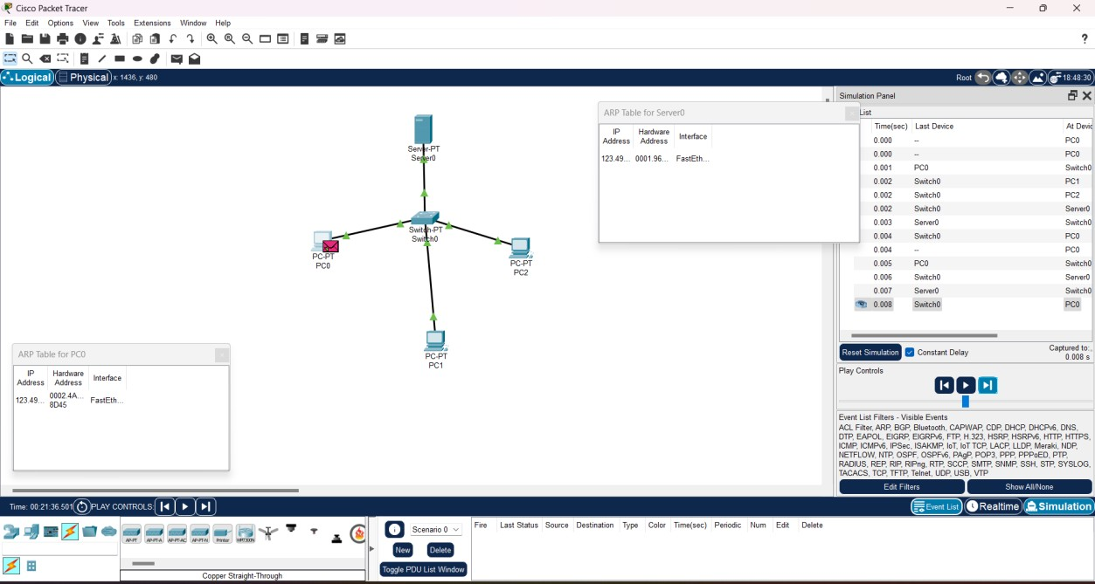

- Data Link Layer Traffic Simulation using Packet Tracer Analysis of LLDP
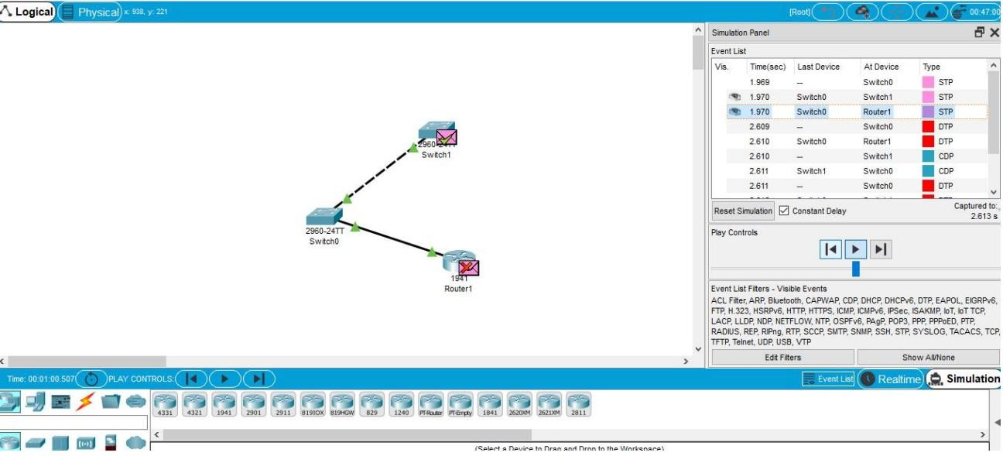

- Data Link Layer Traffic Simulation using Packet Tracer Analysis of CSMA/CD & CSMA/CA
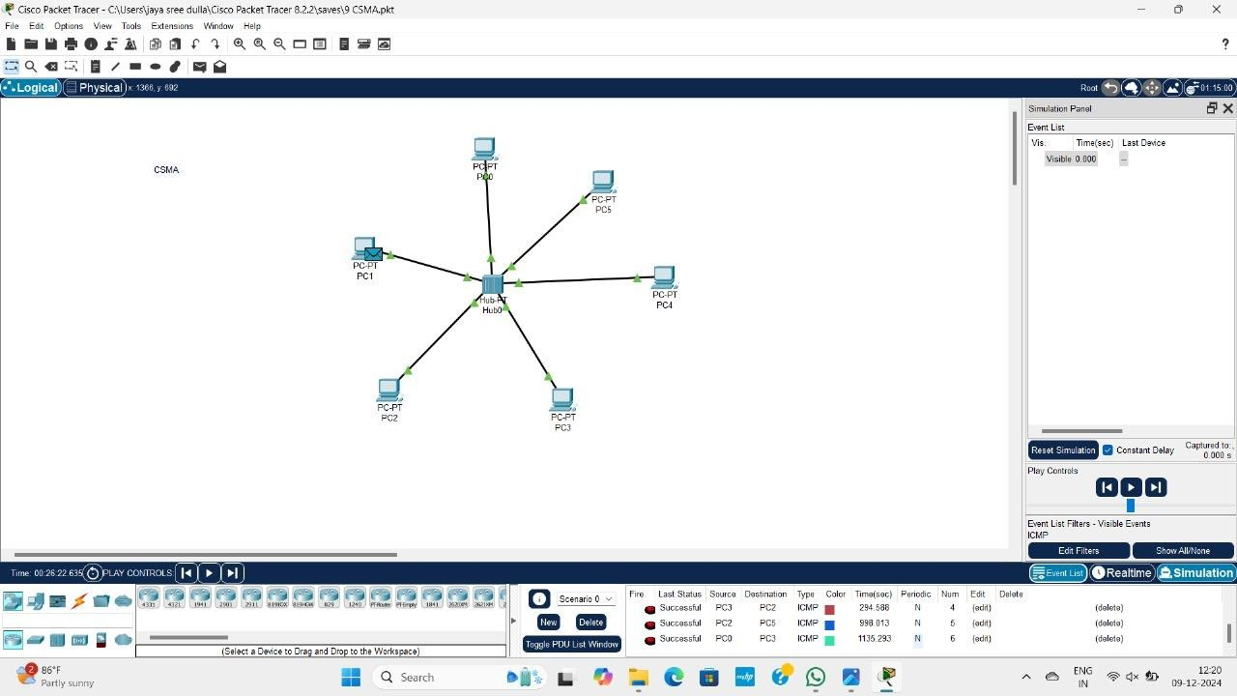

11.Designing two different networks with Static Routing techniques using Packet Tracer.
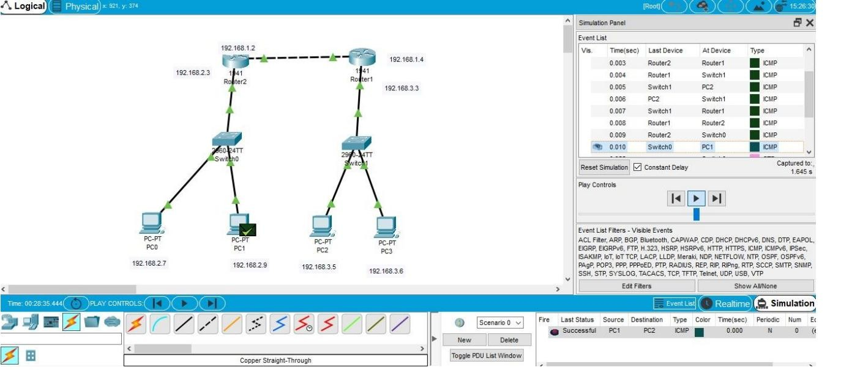

12.Designing two different networks with Dynamic Routing techniques (RIP & OSPF) using Packet Tracer
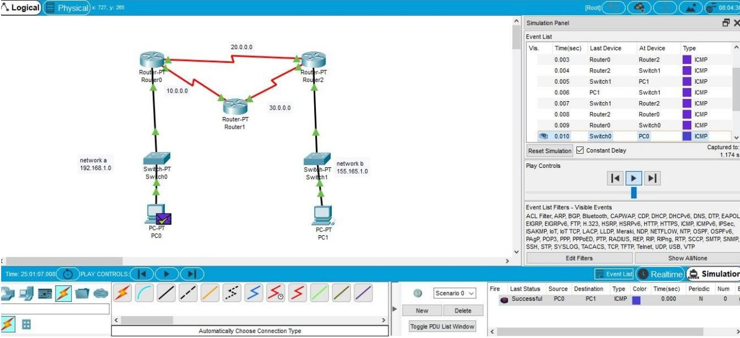

13.Design the Functionalities and Exploration of TCP using Packet Tracer
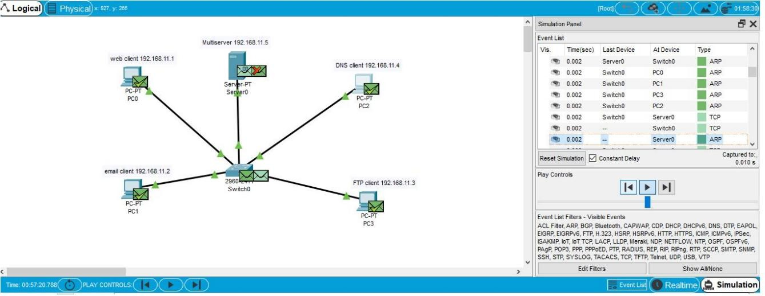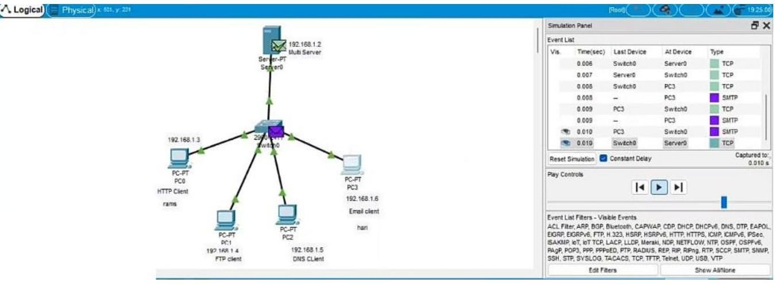

14.Design the Functionalities and Exploration of UDP using Packet Tracer.
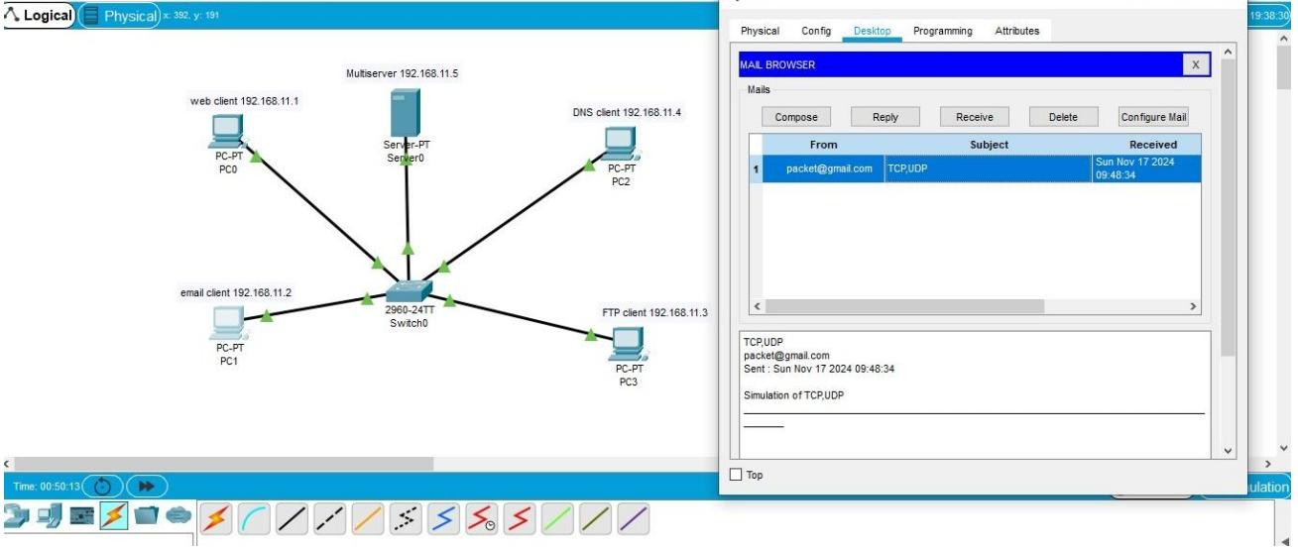
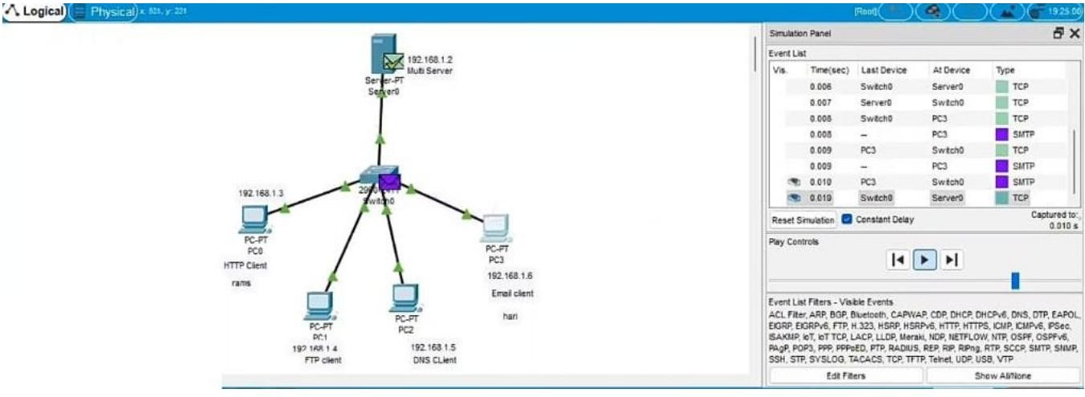

- Design the network model for Subnetting – Class C Addressing using Packet Tracer.
